Assignment-6
1.Find Sum of Array Elements
public class ArraySum {
public static void main(String[] args) {

int[] arr = {10, 69, 30, 40, 50};
int sum = 0;

for (int i = 0; i < arr.length; i++) {
sum = sum + arr[i];
}

System.out.println("Sum of array elements = " + sum);
}
}
OUTPUT
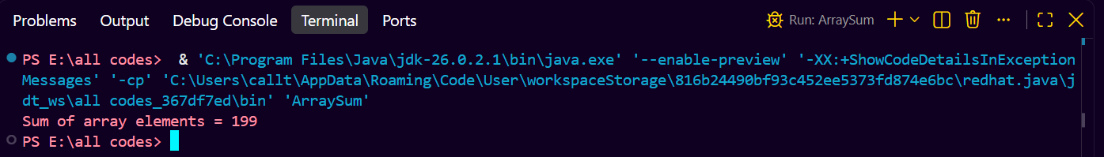

2.Find Largest Element in an Array
public class Array {
public static void main(String[] args) {

int[] arr = {10, 29, 70, 48, 30};

int largest = arr[0];

for (int i = 1; i < arr.length; i++) {
if (arr[i] > largest) {
largest = arr[i];
}
}

System.out.println("Largest element = " + largest);
}
}
OUTPUT
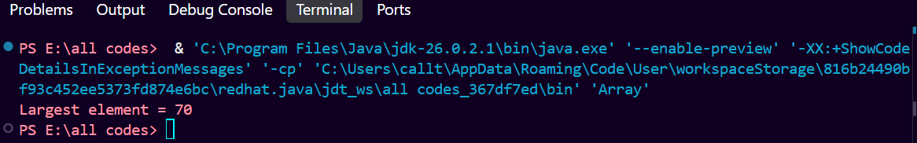
3.Search an Element in an Array
import java.util.Scanner;
public class Array {
public static void main(String[] args) {

Scanner sc = new Scanner(System.in);

int[] arr = {10, 55, 68, 40, 90};

System.out.print("Enter element to search: ");
int key = sc.nextInt();

boolean found = false;

for (int i = 0; i < arr.length; i++) {
if (arr[i] == key) {
found = true;
System.out.println("Element found at index " + i);
break;
}
}

if (!found) {
System.out.println("Element not found");
}

sc.close();
}
}
OUTPUT
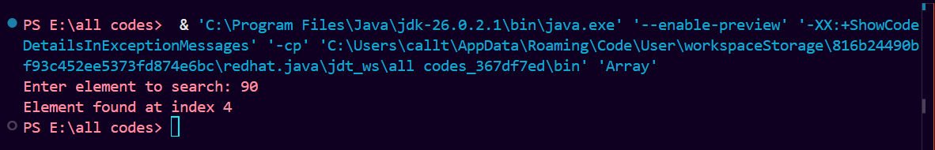
4. Reverse an Array
public class Array {
public static void main(String[] args) {

int[] arr = {10, 20, 30, 40, 50};

System.out.println("Original Array:");

for (int i = 0; i < arr.length; i++) {
System.out.print(arr[i] + " ");
}

System.out.println("\nReversed Array:");

for (int i = arr.length - 1; i >= 0; i--) {
System.out.print(arr[i] + " ");
}
}
}
OUTPUT
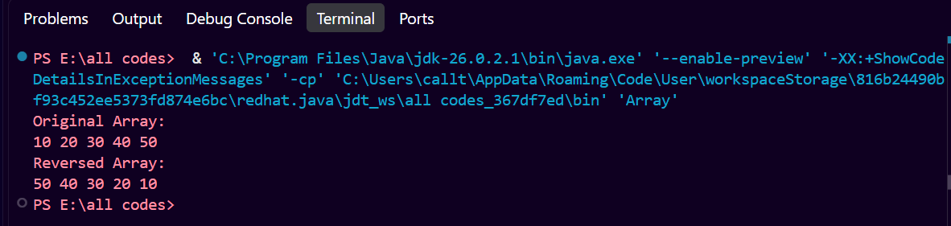
5.Count Occurrence of an element in an Array
import java.util.Scanner;

public class Array {
public static void main(String[] args) {

Scanner sc = new Scanner(System.in);

int[] arr = {10, 20, 10, 30, 10, 40, 20};

System.out.print("Enter element to count: ");
int key = sc.nextInt();

int count = 0;

for (int i = 0; i < arr.length; i++) {
if (arr[i] == key) {
count++;
}
}

System.out.println("Occurrence of " + key + " = " + count);

sc.close();
}
}
